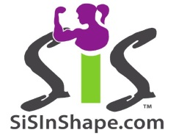
Team Sisters In Shape
Name

City /Province/State/Country
SOME STATS

Age If applicable # of Children (Ages)

Occupation (Title)

Target Competition Date & Location & Federation

Target Category (Bikini/Fitness Model/Figure)

# of Past Competitions Placed?

TELL US ABOUT THE REAL YOU

Why are you competing?

What role does health & fitness play in your life? (now & in the past)

What do you wish you could tell other women to help them on their health & fitness journey?

CONNECTING
Do you have a website, blog, public Facebook page, Twitter or Instagram account you wish to post so others could visit you? If so, list all you would like to share.

YOU BEAUTIFUL!
Be sure to attach a photo you would like to have posted with your profile on sisinshape.com. Select a photo that reflects YOU. Have it show your personality, priorities and/or proud accomplishments (family photo, before & after etc.).
Email: info@sisinshape.com

